

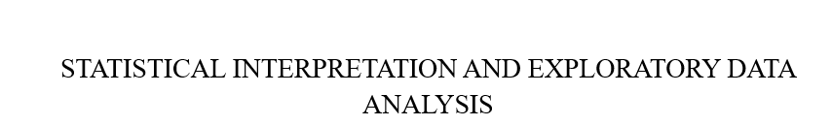

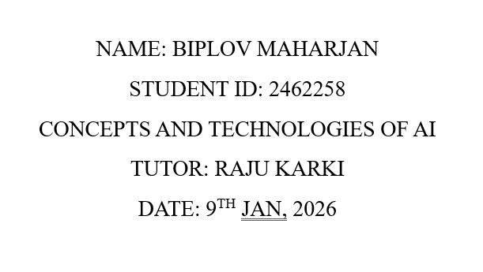

Contents
INTRODUCTION 3
HDI (Human Development Index): 3
Components of HDI (Human Development Index): 3
Why HDI is important 3
Objectives of the Analysis 3
Scope of the report 3
Problem-wise Analysis: 4
Single Year HDI Exploration 4
1. Methods and approach 4
2. Visualizations and tables 4
3. Key results 5
4. Interpretation and discussion 5
HDI Trend Analysis (2020–2022) 5
1. Methods and approach 5
2. Visualizations and tables 5
3. Key results 8
4. Interpretation and discussion 8
Advanced HDI Exploration 8
1. Methods and approach 8
2. Visualizations and tables 8
3. Key results 10
4. Interpretation and discussion 10
Regional Analysis between South Asia and Middle East 11
1. Methods and approach 11
2. Visualizations and tables 11
3. Key results 14
4. Interpretation and discussion 14
Conclusion 14
References 15
Appendix 15

INTRODUCTION

HDI (Human Development Index):
A composite metric used to evaluate a nation's social and economic progress is the Human progress Index (HDI). In 1990, the United Nations Development Program (UNDP) introduced it. In contrast to focusing solely on GDP (income), HDI takes into consideration standard of living, health, and education to present a more comprehensive picture of people's well-being.

Components of HDI (Human Development Index):
There are three major components are:
- Health (life expectancy)
- Education (level of literacy)
- Standard of living (life style)

Why HDI is important
- Focus on the welfare of individuals rather than only economic progress (GDP).
- Aids in comparing living standards between nations.
- Help legislators create improvements to income, education, and health.

Objectives of the Analysis
- To know human Development Levels.
- Determine The Strengths and Weaknesses
- Direct Policy and Decision-Making
- Compare Countries or Regions
- Track Development Over Time

Scope of the report
This report analyzes Human Development Index (HDI) data using Python to understand global development patterns while building practical data analysis skills. By examining relationships between HDI components including health, education, and income, the project develops essential skills in data handling, analysis, and visualization relevant to data science, AI, and advanced analytics.

Problem-wise Analysis:

Single Year HDI Exploration

Methods and approach
The Human Development Index (HDI) for 2022 is examined in this analysis. Data cleaning was done to fix missing values and guarantee reliability after the dataset was filtered to only contain records from the chosen year. To illustrate the differences in global development, descriptive analysis was used to determine which nations had the highest and lowest HDI values. To compare income and development levels, additional research concentrated on nations with HDI values greater than 0.800, which were arranged by GNI per capita. To comprehend the structure and facilitate precise analysis, basic dataset exploration was also carried out.

Visualizations and tables
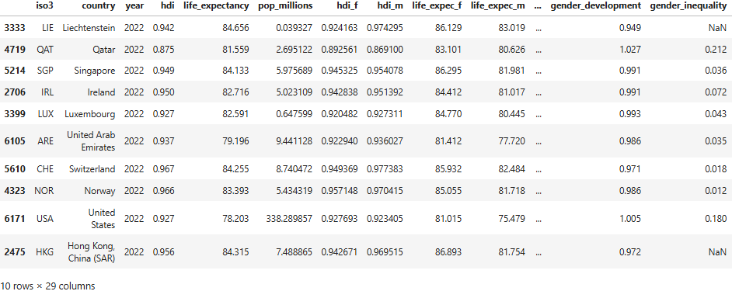
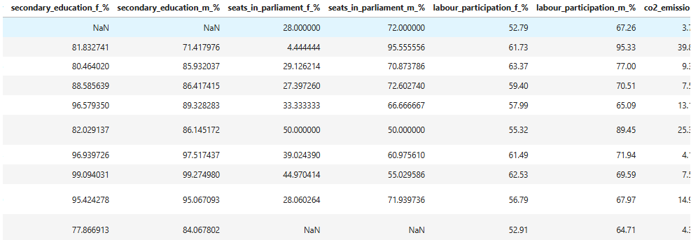
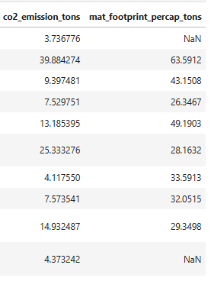
the following images are the final representation of our first problem

Key results
after basic statisics we can see
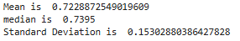

Interpretation and discussion
The output show significant gaps in human development around the world in 2022. There is a strong correlation between income and overall development, as countries with higher HDI values typically have higher GNI per capita. These findings highlight the necessity of concentrated efforts to advance human development in nations with lower HDI scores.

HDI Trend Analysis (2020–2022)

Methods and approach
This analysis examines Human Development Index (HDI) data for the years 2020, 2021, and 2022. The dataset was filtered to include only these years and cleaned to address absent values, inconsistencies, and duplicate records to ensure data reliability. Exploratory analysis and visualizations were then used to study HDI trends across countries and regions, including comparisons over time and relationships between HDI and economic indicators such as GNI per capita. These methods support a perspicuous understanding of development patterns and changes during the selected period.

Visualizations and tables
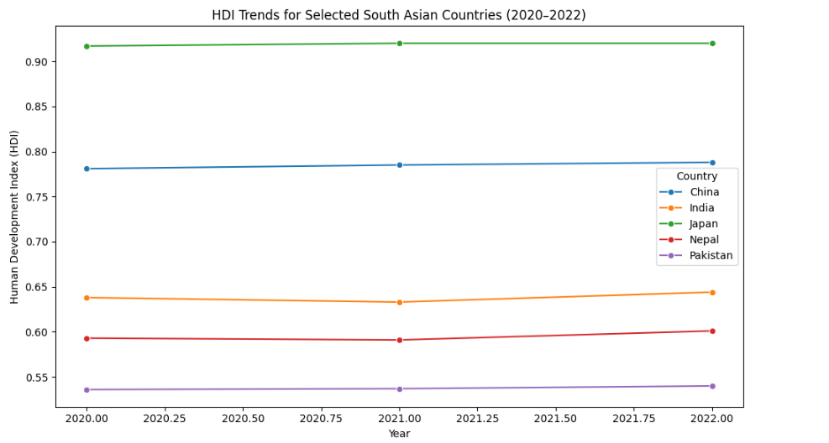
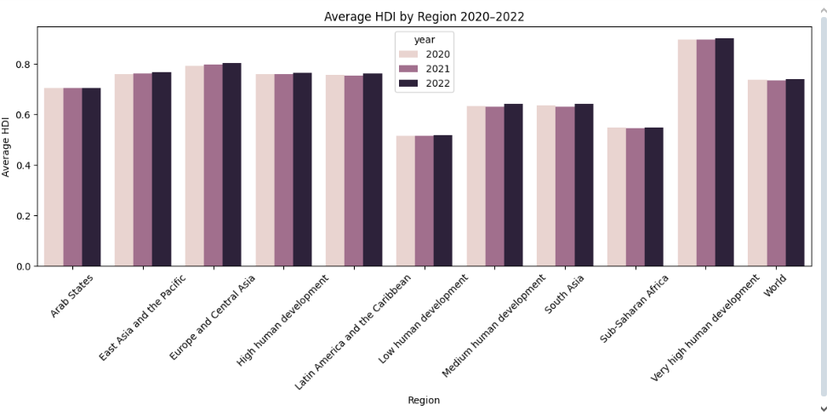
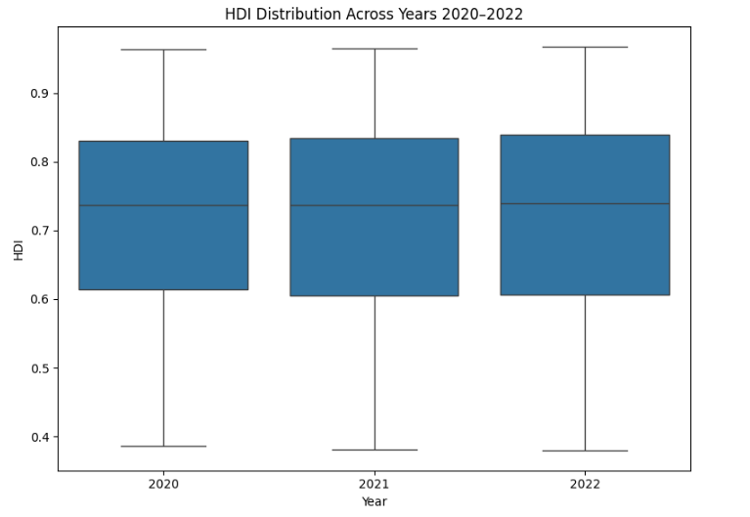
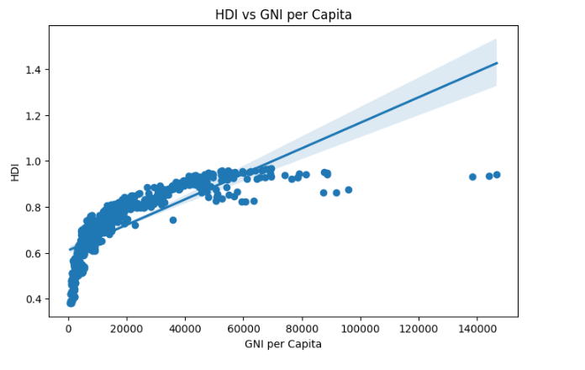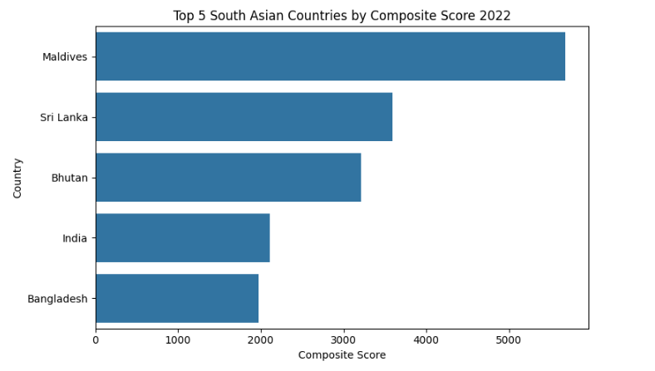

Key results
The COVID 19 pandemic significantly contributed to a decline in overall HDI during 2020–2022

Interpretation and discussion
With high income countries stable and low to middle income countries showing more variation. HDI correlates powerfully with GNI per capita, though some countries achieve high HDI despite infernal income. territorial disparities persist, highlighting the need for targeted development policies.

Advanced HDI Exploration

Methods and approach
The HDI data for South Asian countries was filtered and cleaned for analysis. With top performers visualized in bar charts. Outliers in HDI and GNI were identified using the 1 .5 × IQR rule and highlighted in scatter plots. Relationships between HDI components and gross HDI were examined using Pearson correlation, and a GNI HDI Gap metric was used to assess discrepancies between income and development outcomes.

Visualizations and tables
Ranking South_Asian_countries based on given Score
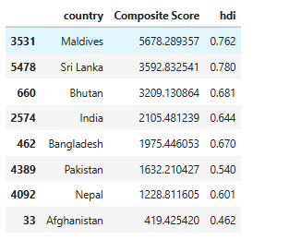

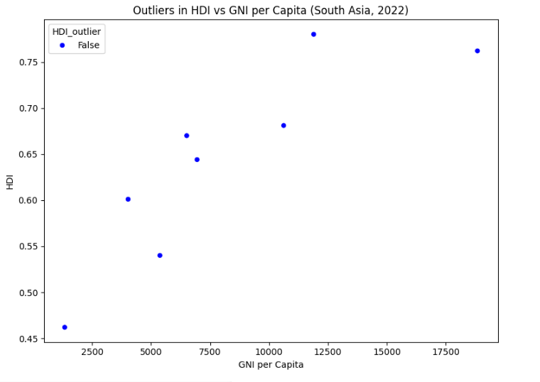
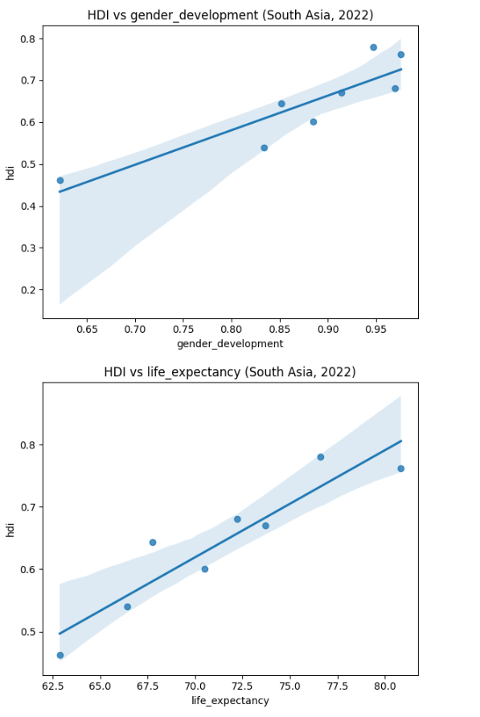

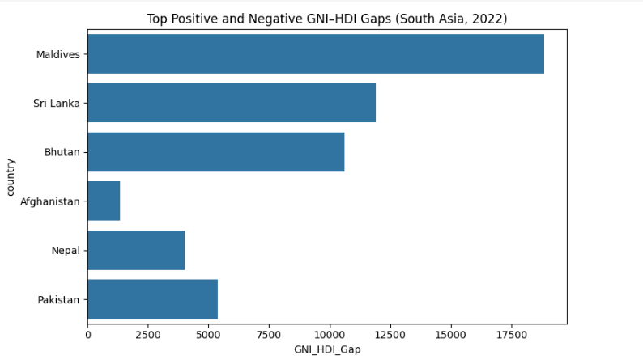

Key results
Between 2020 and 2022, Middle Eastern countries scored higher on the HDI than South_ Asian_countries, and there was a important difference in GNI per capita between the two countries. Optimistic trends show that long life expectancy and greater gender related development are linked to higher HDI levels.

Interpretation and discussion
The analysis shows variation in development across South Asian countries. The Composite Score highlighted top performers, while outliers revealed disparities between income and HDI. Correlation analysis identified which HDI components near influence development and the GNI HDI Gap highlighted cases where income does not fully translate into better weak development outcomes.

Regional Analysis between South Asia and Middle East

Methods and approach
The Middle East and South Asia HDI data from 2020 to 2022 was cleaned and filtered. Bar charts and synchronic data were used to compare top and bottom performers as well as territorial performance. The 1.5 × IQR criterion was used to identify outliers that deviated from territorial patterns, and correlation analysis looked at the correlations between the HDI and its components.

Visualizations and tables
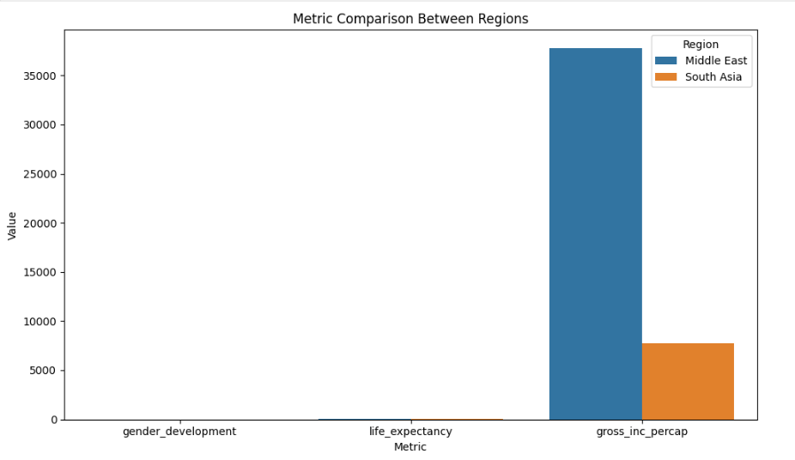
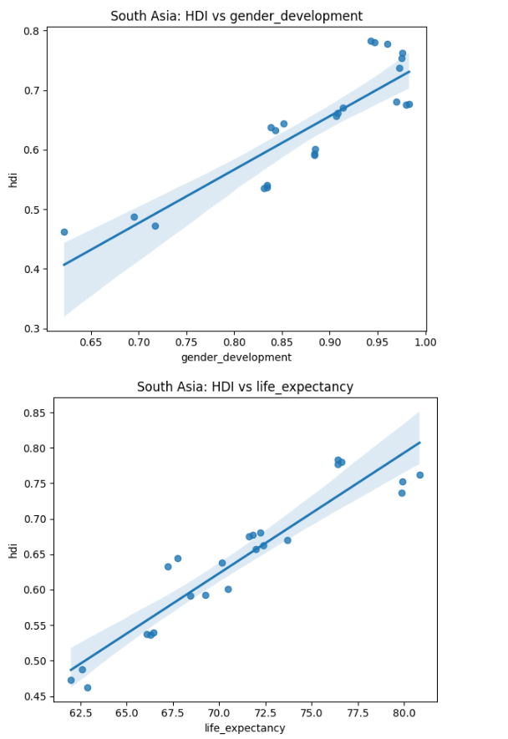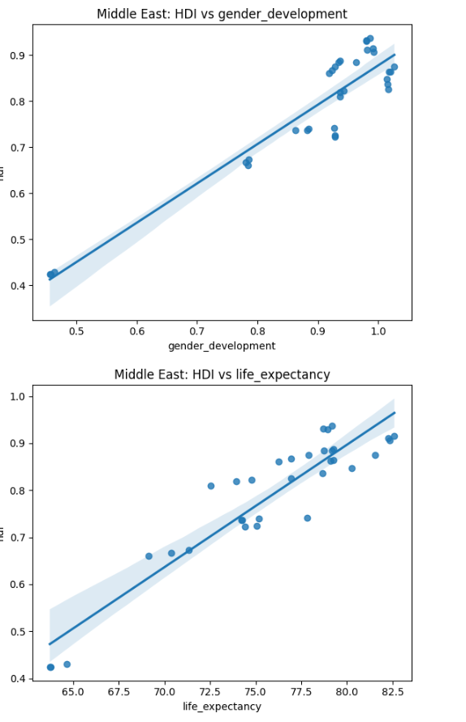
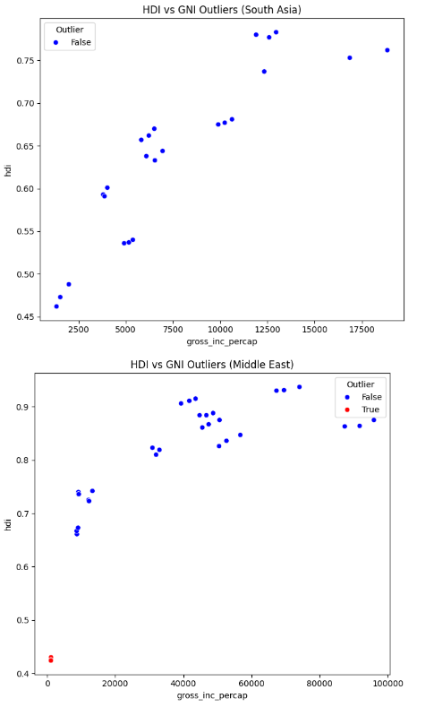

Key results
In general, between 2020 and 2022, Middle Eastern countries scored higher on the HDI than South Asian countries. The Middle East and South Asia had a big difference in GNI per capita. Higher gender development and long-life expectancy are linked to higher HDI levels, according to optimistic trends seen in all the interactions examined.

Interpretation and discussion
According to the analysis, between 2020 and 2022, Middle Eastern countries scored higher on the HDI than South Asian countries. Comparisons of top and bottom performers revealed luminary differences both within and between areas. Countries with abnormally high or low HDI in comparison to their peers were found through outlier detection, informative anomalies in development patterns.

Conclusion
Although some nations differ from this pattern, HDI is positively connected with GNI per capita, life expectancy, and gender development. Although there are differences between countries, the Middle East broadly scores better than South Asia. The impacts of the broad have momently delayed development. Trends and Disparities: Although the HDI represents more broad development indicators, anomalies demonstrate that resources and wealth do not needfully correspond to human development. Compared to South Asia, Middle Eastern nations have higher averages but more variety. Limitations: Long term patterns may not be captured because the analysis is based on current data (2020–2022). Implications: Countries may improve HDI results and lessen inequities by strengthening governance, implementing policies, and making data driven decisions.

References
Python Libraries / Documentation
- Matplotlib (2024). Matplotlib: Python Plotting — Matplotlib 3.1.1 Documentation. [Online] Available at: https://matplotlib.org/
- NumPy (2024). NumPy. [Online] Available at: https://numpy.org/
- Pandas (2018). Python Data Analysis Library. [Online] Available at: https://pandas.pydata.org/
- Seaborn (2012). Seaborn: Statistical Data Visualization — Seaborn 0.9.0 Documentation. [Online] Available at: https://seaborn.pydata.org/

Appendix

